**Idea3588 Development Kit Single Board Computer**

* **Processor:** Rockchip RK3588 octa-core processor, 4x Cortex-A76 cores @ 2.6GHz, 4x Cortex-A55 cores @ 1.8 GHz
* **RAM:** 4GB LPDDR4
* **Storage:** 8GB
* **Interfaces:** 4x USB2.0 Host, 1x USB3.0 Host, 1x USB3.1 Type-C, 2x UART, RS485, CAN, Ethernet, HDMI OUT, HDMI IN, DisplayPort, MIPI CSI, MIPI DSI, PCIe2.0, PCIe3.0, SATA3.0, SD+SIM, Audio I/O, RTC, etc.
* **Operating system:** Android 12
* **Board size:** 165mm x 120mm

**Hardware**

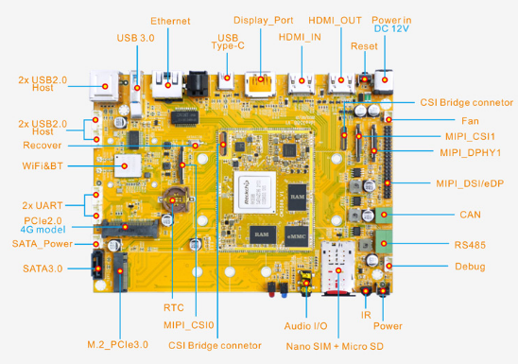

**Specifications**

|  |  |
| --- | --- |
| CPU | Rockchip RK3588. Quad-core Cortex-A76 + Quad-core Cortex-A55 |
| GPU | ARM Mali-G610 GPU MP4 with support for OpenGL ES 1.1/2.0/3.2, OpenCL 2.2, Vulkan 2.2 |
| NPU | 6 TOPS |
| Memory | 4GB LPDDR4 (up to 32GB) |
| Storage | 8GB eMMC flash (up to 128GB) MicroSD card slot 1x SATA3.0 1x M.2 PCIe SSD |
| Power Supply | 12V/3A DC input jack |
| USB | 1x USB3.1 Type-C 4x USB2.0 Host 2.0 (1x Dual-USB AF connector, 2x 4pin connector) 1x USB3.0 Host |
| Connectivity | Gigabit Ethernet RJ45 port via Realtek RTL8211F-CG controller SDIO 2.4G/5G 2T2R WiFi (802.11a/b/g/n/ac) with Bluetooth5.1 Mini PCIe socket with Nano SIM card port to support 4G LTE Modem or PCIe WIFI Modem |
| Serial | 1x Serial port for debug, 3-pin connector 2x UART, 4-pin connectors 1x RS485 |
| Video | **Output:** HDMI 2.1 up to 8Kp60  MIPI DSI/eDP 1.3, 1080p60 (40-pin header)  DisplayPort 1.4, 8Kp30  **Input:** HDMI input, up to 4Kp60  2x MIPI-CSI, 1x DPHY input for camera |
| Audio | 3.5mm audio I/O jack 8-channel audio via HDMI SPDIF out |
| Camera | 3x Cameras, 30-pin FPC connector |
| Keys | Recover, Reset, Power |
| Other features | RTC with battery connector; IR receiver, CAN, RS485 |
| Dimension | Based board – 165 x 120mm; CPU module - 67 x 53mm |
| OS | Android 12 |

**CM3588 CPU Module**

CM3588 is a system-on-module (SoM) based on Rockchip RK3588 octa-core Cortex-A76/A55 processor with 6 TOPS of AI performance and hardware-based maximum 48-Megapixel ISP designed for AR/VR, edge IoT, AIoT, and computer vision applications. The SoM is equipped with 4GB (up to 32GB) RAM and 8GB (up to 128GB) flash, offers Gigabit Ethernet network through RTL8211F-CG controller, and FPC connector for cameras with up to 8K resolution.

**Processor**: Rockchip RK3588 octa-core processor, 4x Cortex-A76 cores @ 2.6GHz, 4x Cortex-A55 cores @ 1.8 GHz  
**RAM**: 4GB LPDDR4  
**Storage**: 8GB  
**Interfaces**: 4x USB2.0 Host, 1x USB3.0 Host, 1x USB3.1 Type-C, 2x UART, RS485, CAN, Ethernet, HDMI OUT, HDMI IN, DisplayPort, MIPI CSI, MIPI DSI, PCIe2.0, PCIe3.0, SATA3.0, SD+SIM, Audio I/O, RTC, etc.  
**Operating system**: Android 12  
**Board size**: 165mm x 120mm

**Specifications**

|  |  |
| --- | --- |
| CPU | Rockchip RK3588, 4x Cortex-A76 cores @ 2.6GHz, 4x Cortex-A55 cores @ 1.8 GHz |
| GPU | ARM Mali G610 MP4. Support OpenGL ES 1.1/2.0/3.2, OpenCL 2.2, Vulkan 1.2 |
| NPU | 6 TOPs |
| Memory | 4/8/16/32GB LPDDR4 |
| Storage | 4/8/16/32/64/128GB |
| Supply Voltage | DC 4V |
| Pin out | 5x UART, USB3.0/2.0 HOST, USB3.1 Type-C, Ethernet, MIPI CSI, MIPI DSI, MIPI DPHY, HDMI TX/RX, DP, I2C, I2S, PCIe3.0/2.0, SATA3.0, SDMMC, SDIO, PWM, CAN, GPIO, etc. |
| Ethernet | GMAC (10/100/1000M) |
| PCB Layer | 10 |
| Dimensions | 60 x 45mm |
| Weight | 11.1 gram |
| Package | 230pin, 1.0 mm pitch, and 39pin FPC connector (For Camera) |
| Application | AR/VR, edge IoT, AIoT, and computer vision applications. |
| Development Board | [Idea3588](http://www.armdesigner.com/Idea3588_SBC/) |
| Operating system | Android 12 |